Greetings!
As we move forward in this year of Kiwanis, I’m challenging myself to do my part in making sure we remain the great club that we’ve always been. However, I need your help.

Here is a question for each of us. WHO are we and WHY are we here? Not just as a club, but also as individual members. What is the WHY for each one of us? The K-Blast mission above implies providing service to the community. That’s important, but what about us? We’re important too! We are part of the community we serve. Taking a step further, we are a heroic pillar in our community!

In his book The Hero Code, retired Navy Admiral William H. McRaven presents 10 codes to be a hero. The first is Courage: I will always strive to be courageous; to take one step forward as I confront my fears. McRaven quoted Winston Churchill, “Courage is rightly esteemed the first of human qualities, because it is the quality which guarantees all the rest.” Let me know your thoughts. (Watch for the second code next month.)

We lost a courageous Kiwanian this month with the passing of Janet Lee. Her passionate career in music, her deep faith in her church, and her love of Kiwanis touched the lives of many people. She made a difference with her courage and her energy. She knew that, and it was her driving passion. We miss her! With her leaving, she left us with a challenge: Know who we are, and utilize our energies and talents to keep our Kiwanis club moving forward!
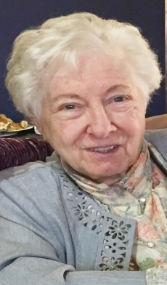

Changing gears, we are one month into our new Kiwanis year. Cheese orders are in for our first fund raiser. Nut sales will be in time for the holidays. Plans are being made for our annual Bell Ringing for the Salvation Army. Interclubs will be scheduled.

We started our new year on October 5 with installation of our officers and Doug Ingles taking the helm as President.
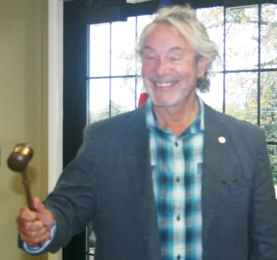

Abbie Jones, a Senior from North Adams High, was honored as Student of the Month at our next regular meeting on October 19.
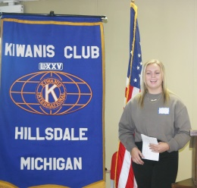

Also on the 19th, Amy Bayer gave us valuable insight into the Hillsdale County Hospice program.
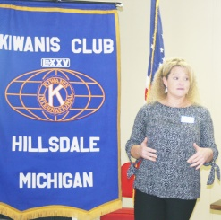

At our 1st social meeting at Johnny T’s on the 28^{th,} we mixed, shared ideas, and welcomed family and friends. 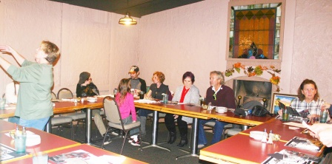
Gifted Gardens displayed some of their marvelous gifts. 

Published by Ed Wolfe
Membership Chair
Edwolfe106@sbcglobal.net
734-775-4041

